2. The Visual Basic Express Design Environment


Review and Preview

In Class 1, we learned the important parts of a Visual Basic Express project. We saw that a project is built on a form using controls (also called objects).

By interacting with the controls using events, we get the computer to do assigned tasks via instructions we provide. In this second class, we will learn the beginning steps of building our own Visual Basic Express projects by looking at the different parts of the project and where they fit in the Visual Basic Express design environment. Like Class 1, there are also a lot of new terms and skills to learn.

Parts of a Visual Basic Express Project

In Class 1, we saw that there are four major components in a Visual Basic Express application: the solution, the project, the form, and the controls. A solution can contain multiple projects. In this course, solutions will only contain a single project, so the words solution and project are used interchangeably. Project is the word used to encompass everything in a Visual Basic Express project. Other words used to describe a project are application or program. The form is the window where you create the interface between the user and the computer. Controls are graphical features or tools that are placed on forms to allow user interaction (text boxes, labels, scroll bars, command buttons). Recall the form itself is a control. Controls are also referred to as objects. Pictorially, a project is:

Control
Control
Control
Control
Project
Form
Control

So, in simplest terms, a project consists of a form containing several (and some projects contain hundreds) controls.

Every characteristic of a control (including the form itself) is specified by a property. Example control properties include names, any text on the control, width, height, colors, position on the form, and contents. Properties are used to give your project the desired appearance. For each control studied in this class, we will spend a lot of time talking about properties.

In Class 1, we saw that by interacting with the controls in the Sample project (clicking buttons, choosing different options, typing text), we could make things happen in our project by generating control events. We say that Visual Basic Express is an event-driven language and it is governed by an event processor. That means that nothing happens in a Visual Basic Express project until some event occurs. Once an event is detected, the project finds a series of instructions related to that event, called an event procedure. That procedure is executed, then program control is returned to the event processor:

Event processor
Event?

Event
Procedure
Event
Procedure
Event
Procedure
Event
Procedure

Event procedures associated with various controls are where we do the actual computer programming. These procedures are where we write BASIC language statements. You will learn a lot of programming and BASIC language in this class. The BASIC you will learn is very similar to the original BASIC used by Bill Gates and Paul Allen when starting Microsoft.

In summary, the major parts of a Visual Basic Express project are:

- form
- controls
- control properties
- control event procedures

Now, let’s take a look at the Visual Basic Express programming environment and identify where we can access each of these project components.
Parts of the Visual Basic Express Environment

Visual Basic Express is more than just a computer language. It is a project building environment. Within this one environment, we can begin and build our project, run and test our project, eliminate errors (if any) in our project, and save our project for future use. With other computer languages, many times you need a separate text editor to write your program, something called a compiler to create the program, and then a different area to test your program. Visual Basic Express integrates each step of the project building process into one environment. Let’s look at the parts of the Visual Basic Express environment. To help in this look, we first need to get a new project started. We won’t do anything with this project. We just use it to identify parts of the Visual Basic Express environment.

Starting a New Visual Basic Express Project

Every time you want to build a project using Visual Basic Express, a first step is to create a new project. Start Visual Basic Express using the procedure learned in Class 1. We start a new project also using the toolbar under the Visual Basic Express menu. Look for this button (the first button on the left):

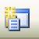
New Project Toolbar Button

You can also start a new project by selecting File from the menu, then clicking New Project.

Click the New Project button and a New Project box appears:

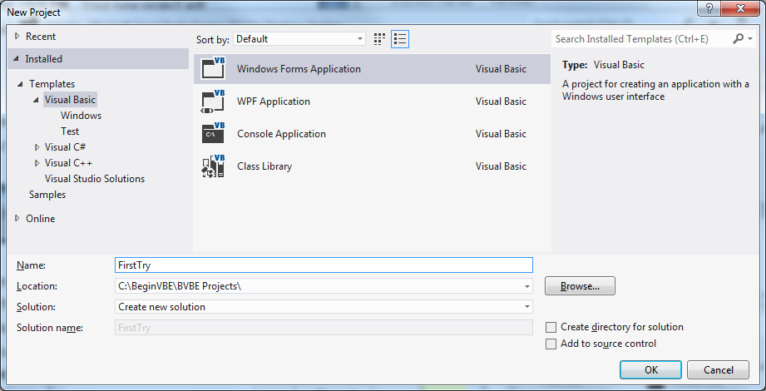s

Under Installed Templates, make sure Visual Basic is selected. We will always be building windows applications, so select Windows Forms Application.

This window also asks where you want to save your project. In the Name box, enter the name (I used FirstTry) of the folder to save your project in. Location should show the directory your project folder will be in. You can Browse to an existing location or create a new directory by checking the indicated box. For these notes, we suggest saving each of your project folders in the same directory. For the course notes, all project folders are saved in the \BeginVBE\BVBE Projects folder. Once done, click OK. Your new project will appear in the Visual Basic Express environment, displaying several windows.

Main Window

The Main Window is used to control most aspects of the Visual Basic Express project building and running process:

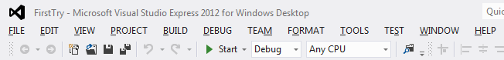

The main window consists of the title bar, menu bar, and toolbars. The title bar indicates the project name (here, FirstTry). The menu bar has drop-down menus from which you control the operation of the Visual Basic Express environment. The toolbars have buttons that provide shortcuts to some of the menu options. You should be able to identify the New Project button. Also, look for the buttons we used in Class 1 to start and stop a project.

Solution Explorer Window

The Solution Explorer Window shows which files make up your project:

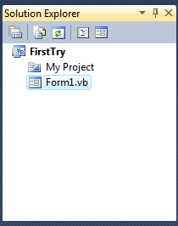

If the Solution Explorer window is not present on the screen, click View on the main menu, then Solution Explorer. As an alternate, if the window does not show up, press the R key while holding down <Ctrl>. If you select the form file (Form1.vb), you can obtain a view of the project form by clicking the View Designer button at the top of the window. Or, you see the actual BASIC coding within a form by clicking the View Code button. We will look at this code window soon.

Design Window

The Design Window is central to developing Visual Basic Express applications. It is where you build your form and write actual code. You should see a blank form in this window:

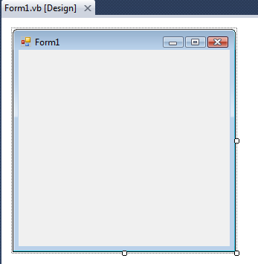

If the form is not present on the screen, select Form1.vb in the Solution Explorer window. Then, click View on the main menu, then Designer. Or, press the <F7> function key while holding down <Shift>.

Toolbox Window

The Toolbox Window is the selection menu for controls used in your application. Many times, controls are also referred to as objects or tools. So, three words are used to describe controls: objects, tools, and, most commonly, controls.

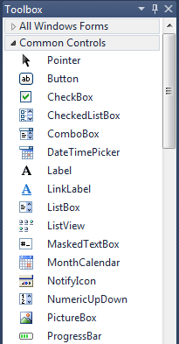

If the toolbox window is not present on the screen, click View on the main menu, then Toolbox. Make sure you are viewing the Common Controls. See if you can identify some of the controls we used in Class 1 with our Sample project.

Properties Window

The Properties Window is used to establish initial property values for controls. The drop-down box at the top of the window lists all controls on the current form. Under this box are the available properties for the currently selected object (the Form in this case). Different views of the properties are selected using the toolbar near the top of the window. Two views are available: Alphabetic and Categorized. We will always used the Alphabetic view.

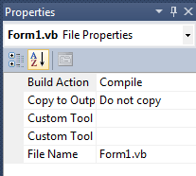
Drop-down
list box
Click here for
Alphabetic view
Properties button

If the properties window is not present on the screen, click View on the main menu, then Properties Window. Click the Properties button (next to the Alphabetic view button) to see the properties. As an alternate, if the window does not show up, press the F4 function key. Note the properties window will only display when the form and any controls are displayed in the Design window.

You should be familiar with each of the Visual Basic Express environment windows and know where they are and how to locate them, if they are not displayed. Next, we’ll revisit the project we used in Class 1 to illustrate some of the points we’ve covered here.
Moving Around in Visual Basic Express

Solution Explorer Window

Open the project named Sample that we used in Class 1 (use the File menu option, then select Open Project reviewing the steps in Class 1 if needed). Once Sample is opened (recall it is in the Sample folder in the \BeginVBE\BVBE Projects folder), find and examine the Solution Explorer window:
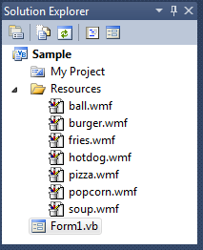

The Solution Explorer window indicates we have a solution with a project file named Sample. The project contains a single form saved as Form1.vb. The project also includes a file named My Project and a folder named Resources containing several graphics files (the ones with wmf extensions). The only file we’re really worried about for now is the form.

Properties Window

Now, find the Properties window. Remember it can only be shown when the form is displayed. So, you may have to make sure the form is displayed first. Review the steps that get the desired windows on your screen.

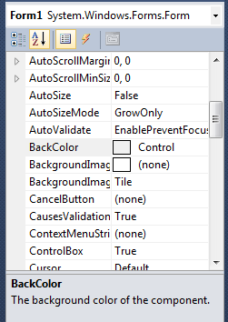
Control list

The drop-down box at the top of the properties window is called the control list. It displays the name (the Name property) of each control used in the project, as well as the type of control it is. Notice, as displayed, the current control is the Form and it is named Form1. The properties list is directly below this box. In this list, you can scroll (using the scroll bar) through the properties for the selected control. The property name is on the left side of the list and the current property value is on the right side. Scroll through the properties for the form. Do you see how many properties there are? You’ll learn about many of these as you continue through the course. Don’t worry about them for now, though.
Click on the down arrow in the control list (remember that’s the drop-down box at the top of the properties window):

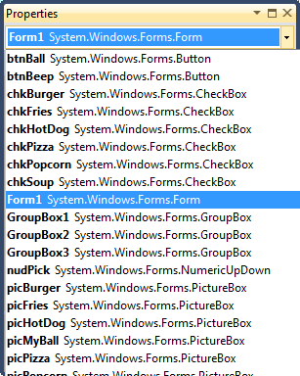

Scroll through the displayed list of all the controls on the form. There are a lot of them. Notice the assigned names and control types. Notice it’s pretty easy to identify which control the name refers too. For example, picBurger is obviously the picture box control holding a picture of a burger. We always want to use proper control naming - making it easy to identify a control just by it’s name. We’ll spend time talking about control naming in the later classes.

Select a control and scroll through the properties for that control. Look at the properties for several controls. Notice every control has many properties. Most properties are assigned by default, that is the values are given to it by Visual Basic Express. We will change some properties from their default values to customize them for our use. We will look at how to change properties in Class 3.
Code Window

Let’s look at a new window. Recall Visual Basic Express is event-driven - when an event is detected, the project goes to the correct event procedure. Event procedures are used to tell the computer what to do in response to an event. They are where the actual computer programming (using the BASIC language) occurs. We view the event procedures in the Code Window. There are many ways to display the code window. One way is to use the View Code button found in the Solution Explorer window. Another is to click View on the main menu, then Code. Or, as an alternate, press the F7 function key. Find the code window for the Sample project. It will appear in the design window under the Form1.vb tab:
Procedure List
Object List
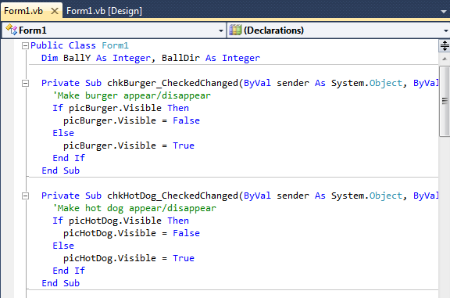

At the top of the code window are two boxes, the object (or control) list and the procedure list. The object list is similar to the control list in the properties window. It lists all objects on the form by name. Once an object, or control, name is selected in that list, the procedure list shows all possible event procedures for that control. Click on the drop-down arrow in the objects list. Select rdoBlue as the object. Select CheckedChanged as the procedure. You should see this:

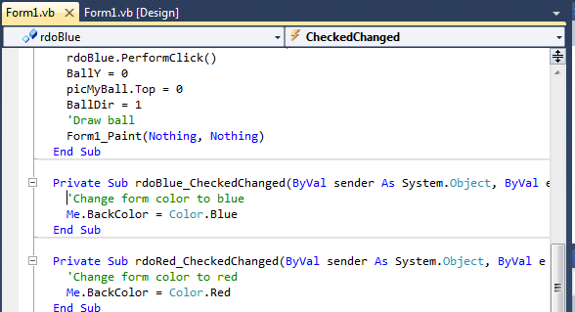

Near the middle of the code window is the CheckedChanged event procedure for the control name rdoBlue. And even though you may not know any BASIC right now, you should be able for figure out what is going on here. Since we will be careful in how we name controls, you should recognize this control to be the radio button (one with a little circle) with the word Blue next to it (the word next to a radio button is its Text property). The status of a radio button (whether it is selected or not) is called its Checked property. So, this event procedure is called whenever we click on the Blue radio button and change its Checked property.
Notice the procedure has a single line of instruction (ignore the other lines for now):

Me.BackColor = Color.Blue

What this line of BASIC code says is set the BackColor property of the control named Me (a word used by Visual Basic Express to refer to the form) to Blue (represented by the words Color.Blue). Pretty easy, huh?

Choose the rdoBlue button again in the Object list, then click on the drop-down arrow in the procedures list box. Notice all the other possible event procedures for the rdoBlue control. Fortunately, we don’t have to write BASIC code for all of these procedures. We only write code for events we expect will happen when our project is running.

Scroll through the other code in the code window. Much of this code might look like a foreign language right now and don’t worry - it should! You’ll be surprised though that you probably can figure out what’s going on even if you don’t know any BASIC. In subsequent classes, you will start to learn BASIC and such code will become easy to read. You’ll see that most BASIC code is pretty easy to understand. Writing BASIC code is primarily paying attention to lots of details. For the most part, it’s very logical and obvious. And, you’re about to start writing your own code!

Summary

In this second class, we’ve learned the parts of the Visual Basic Express environment and how to move around in that environment. We’ve also learned some important new terms like properties and event procedures. You’re now ready to build your first Visual Basic Express project. In the next class, you’ll learn how to place controls on a form, move them around, and make them appear just like you want. And, you will learn the all-important step of how to put BASIC code in the event procedures.

